

**Lab Manual- Setup and Manage Azure SQL Database**

**Prepared for**:

**Date:** 18th Nov 2021

**Prepared by:**

Document Name: Lab Manual **Document Number** AZLab981

**Contributor:**

Contents

1. Introduction 2

2. How to Create Free SQL Database in Azure 3

3. Query the SQL database in Azure 9

4. How To Create Tables In SQL Azure Database 10

## Introduction

Microsoft Azure SQL Database is an excellent, scalable, durable, intelligent database service that is built for the Cloud. Microsoft takes care of resource management, Storage Size, Infrastructure, etc.

Another most important part is, the resources scale on-demand automatically and it’s always up to date and AI-Driven.

In this Lab we are going to deploy Azure SQL database and Create Basis Operation.

## How to Create Free SQL Database in Azure

Follow the below steps to create a free SQL Database in Azure.

**Step-1:** Login to the **Azure portal (https://portal.azure.com/)**

**Step-2:** Search for **Azure SQL** and select it .

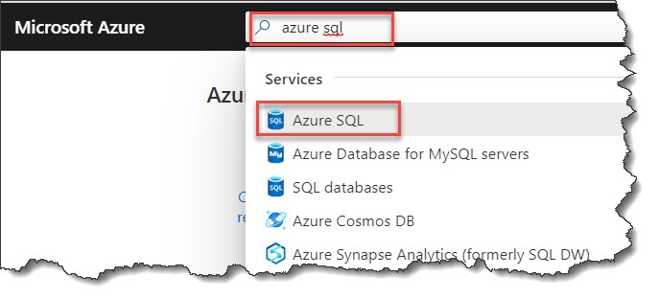**Create an Azure SQL database**

**Step-3:** Click on the **Add** button On the **Azure SQL** page.

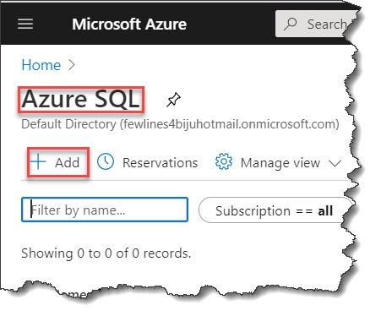

**Step-4:** On the **Select SQL deployment option** window, click on the**Create**button from the SQL database option.

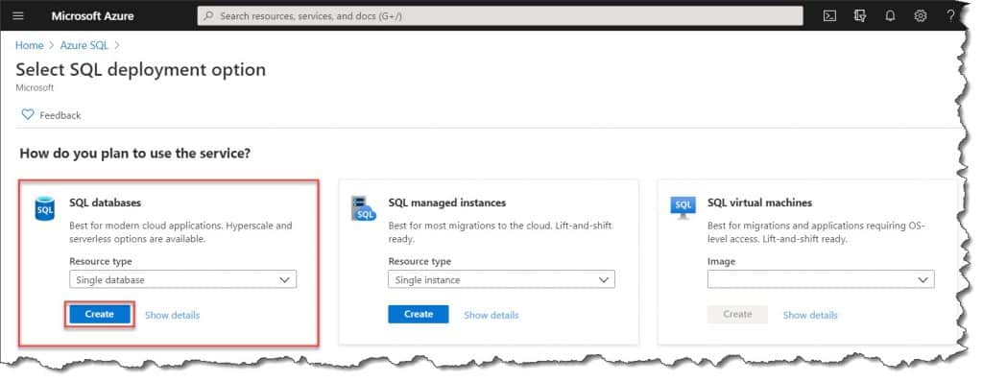

**Step-5:** On the **Basics**, Fill the below details.

* **Subscription:**Select the correct subscription.
* [**Resource gr**](https://azurelessons.com/what-is-resource-group-in-azure/)oup: Create a new resource group by clicking on the Create new link.
* Database name: Provide a meaningful database name.

**Server:**Click on the **Create new** link to create a new server. Enter the below details on the **New server** form.

* **Server name**: Enter a unique server name
* **Server admin login**: Enter *azure user*.
* **Password**: Enter a **password**and enter it again in the **Confirm password** field.
* **Location**: Choose a location here

Click on the **OK**button

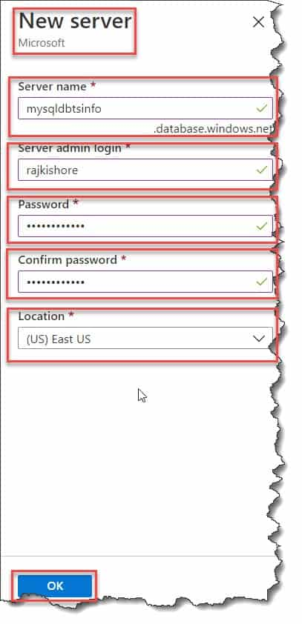

**Step-6:** **Compute + storage**: It will load a default one. if you want to reconfigure the defaults, select **Configure database** link.

On the **Configure** page, you can choose the below details.

* You can change the **Compute tier** from **Provisioned** to **Serverless**.
* Change the settings for **vCores** and **Data max size**.
* Click on the **Change configuration** button to change the hardware generation.

Now click on the **Apply**.

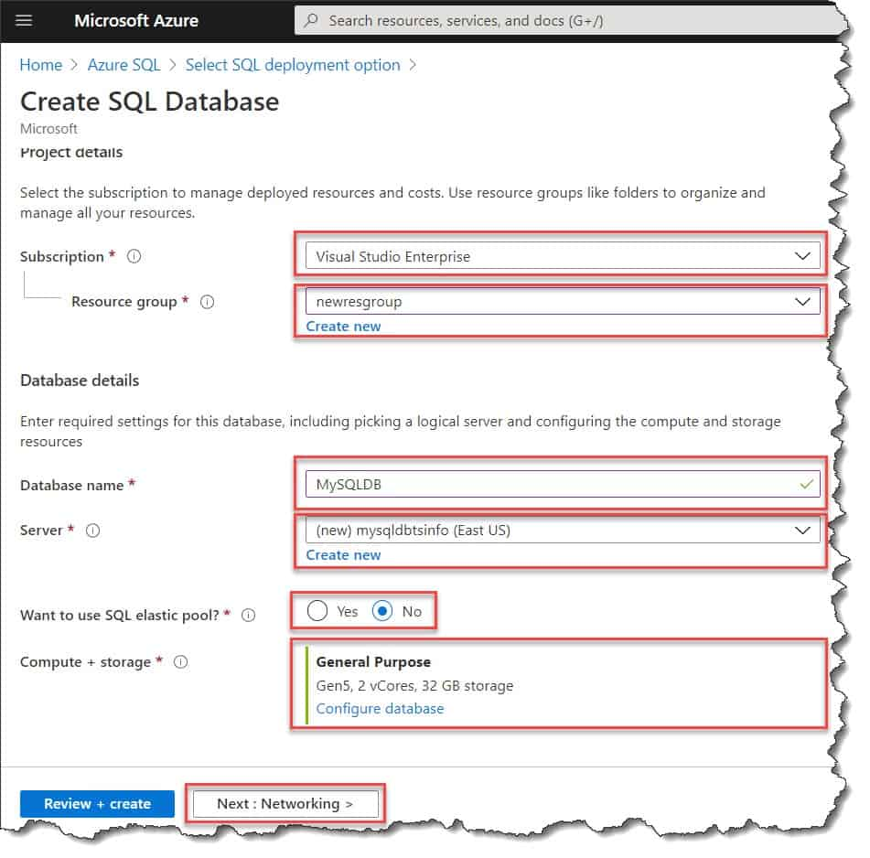

**Step-7:** Click on the **Next:Networking>**button to go the Networking tab.

In the Networking tab, Choose the below options

* Select the **Connectivity method** as **Public endpoint**.
* Choose the **No** option for **Allow Azure services and resources to access this server**.
* Select **Yes** option for **Add current client IP address**.

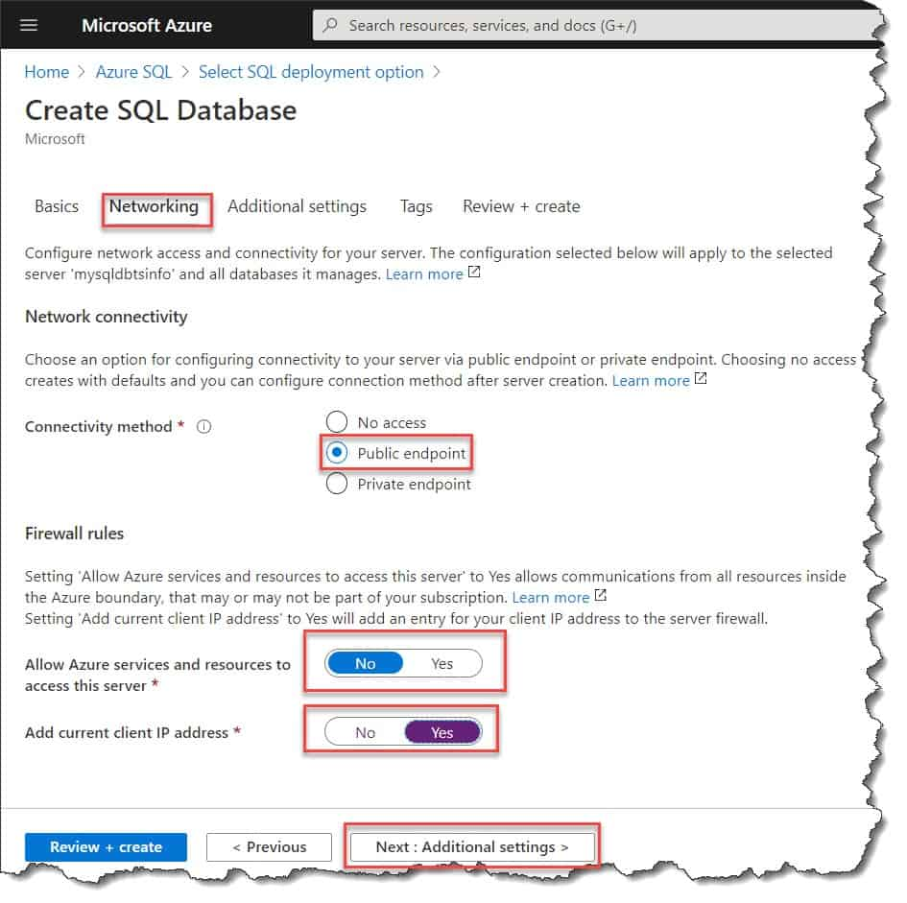

**Step-8:** Click on **Next : Additional settings >** button to go to **Additional settings** page

* Select the **Sample** option for **Use existing data**
* Click on the **Review + Create** button.

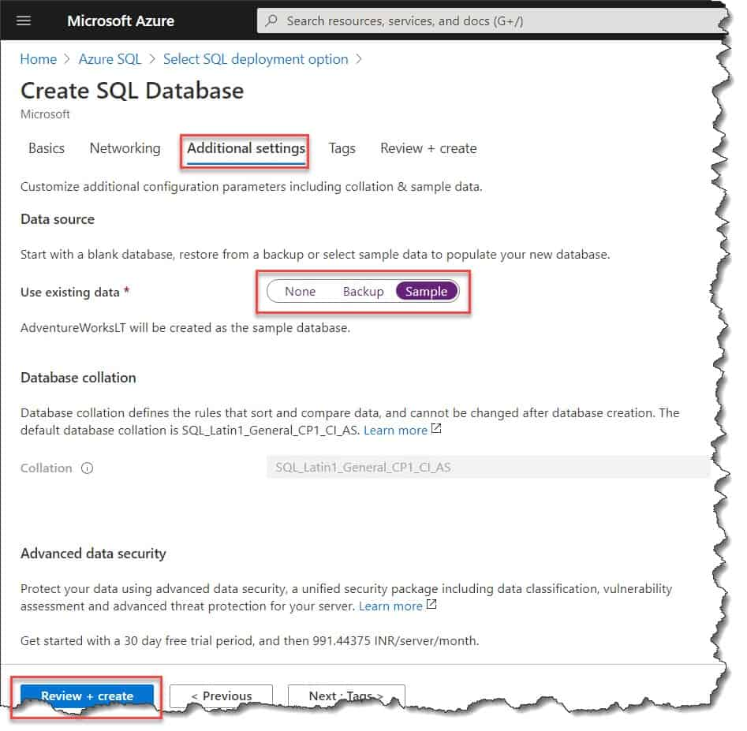

**Step-9:** Finally, click on the **Create** button which will create the **Azure SQL database**.

**Note:**Do not forget to read the terms properly before clicking on the **Create** button.

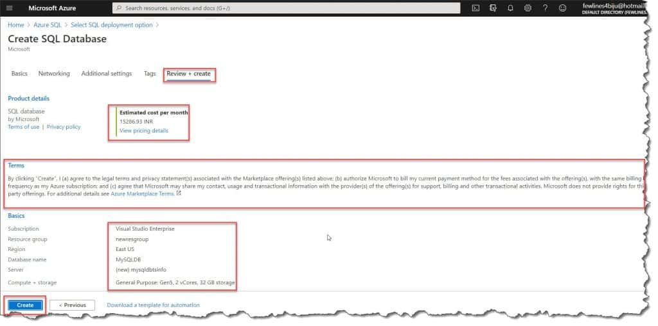

This is how we can create **Microsoft Azure SQL Database Step By Step**.

## Query the SQL database in Azure

Once your data base is created by using the above steps, now time to query the database.

To query the database follow the below steps.

**Step-1:** Login to the **Azure portal** and search for **SQL databases** and select it.

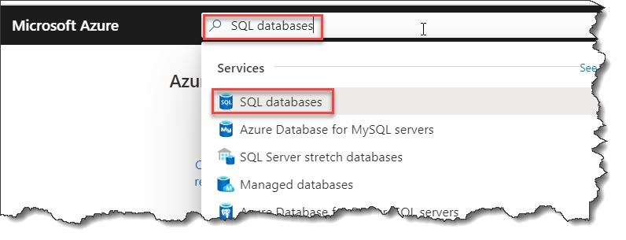

**Step-2:** From the **SQL databases** **window** select the **database** you have created.

**Step-3:** Select the **Query editor (preview)** option from the left menu from the database page.

**Step-4:** Enter your **credentials** under **SQL server authentication**which you have generated earlier on the **New server** page and then click on the **OK** button.

**Step-5:** Enter your **SQL query** in the **query editor** and then click on the **Run** button to execute the query. It will show the output at the **Results** pane.

## How To Create Tables In SQL Azure Database

Now, the time to create a table in Azure SQL database. Follow the below simple steps to create a table in Azure SQL DB.

1. Connect to **Azure SQL DB Instance** using **SQL Server Management Studio (SSMS)**
2. Locate the**Database node** –>**Right-click**on the **Database**–> click on the**New Query** option.

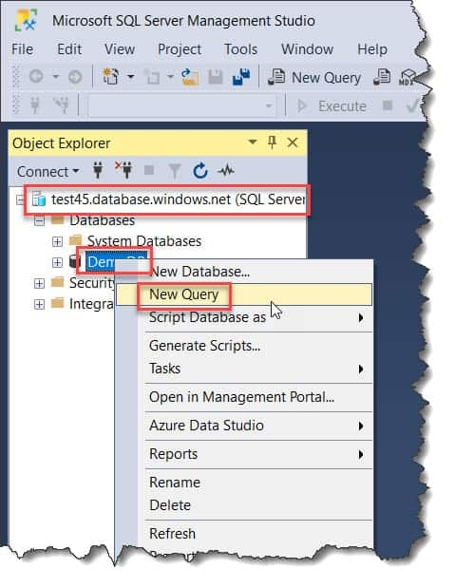

3. On the Query window, write the query as below.

CREATE TABLE Student

(

StudentId INT IDENTITY PRIMARY KEY,

FirstName NVARCHAR(128) NOT NULL,

LastName NVARCHAR(128) NOT NULL,

DateOfBirth DATE NOT NULL

)

4. After writing the Query click on the Execute button as shown below.

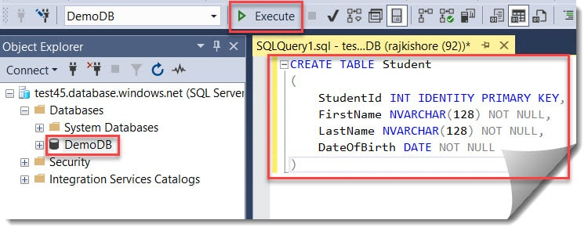

5. Now, you can able to see that it is showing **Commands completed successfully**.

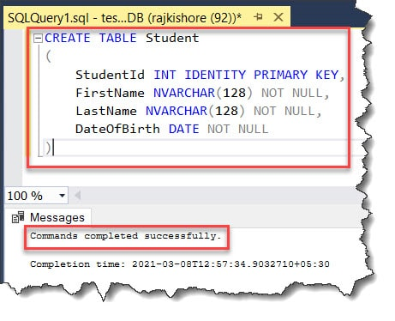

6. To, verify if the table is created, you can expand the **Database node –> Expand the Tables –>** You can able to see the **dbo.Student** table has been created successfully without any issue.

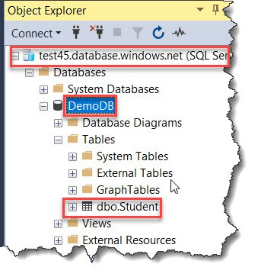

This is **How To Create Tables In SQL Azure Database**.